BLUE/OCEAN ECONOMY WORK PLACEMENTS, INDUSTRY EXPERIENCE AND INTERNSHIPS JANUARY 2019

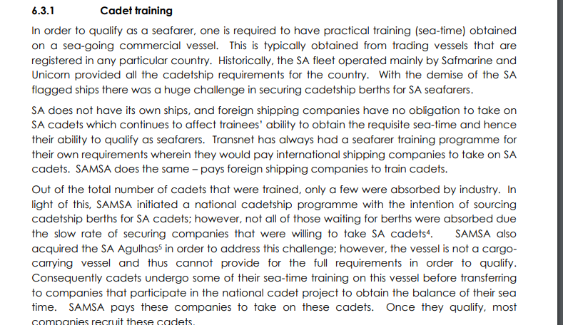
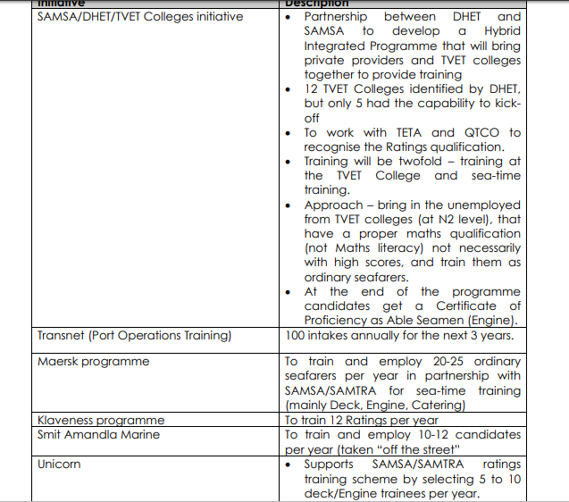
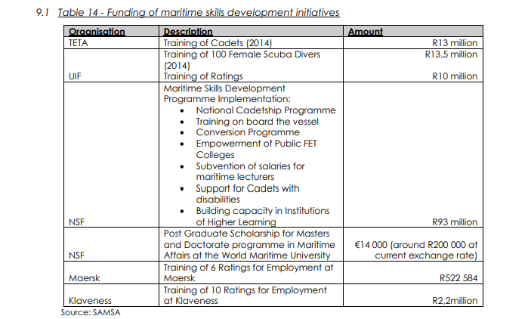

Wilhelmsen

https://www.wilhelmsen.com/careers/

DAL Shipping

Sea Jobs
• Deck- and Engine Officers (m/f) with Chemical Tanker experience - Due to the expansion of our Chemical Tanker fleet we are looking for highly qualified and motivated Deck- and Engine officers (m/f) with Chemical Tanker experience to join us. -more details..

Shore Jobs
• Sachbearbeiter (m/w/d) Liner Accounting - Wir suchen zum nächstmöglichen Zeitpunkt unbefristet einen Sachbearbeiter (m/w/d) Liner Accounting. - more details..
• Buchhalter (m/w/d) -

Apprenticeships
• Schifffahrtskaufmann/-frau Linienfahrt / Trampfahrt - We are looking for motivated and committed apprentices starting their apprenticeship as Schifffahrtskaufmann/-frau Linienfahrt or Trampfahrt on 1st August 2019. - more details..

Internships
• We currently have no vacancies. Please check our website again in the future.

HAMBURG SUD

Foundation for a successful career
With a total of five dual apprenticeships, two courses within the dual work-study program, and internships, Hamburg Süd lets you create the foundation for a successful career. In addition to their schooling, our apprentices gain experience in various departments in order to win extensive insights into the daily work. Upcoming shipping agents also have the opportunity to spend several weeks at a Hamburg Süd office in Europe and to gather their first international work experience. For those who would like to start working while studying, immediately upon high school graduation, we offer the opportunity at Hamburg Süd to choose one of two dual work–study courses.

Dual apprenticeships at Hamburg Süd
TRAINING is writ large at Hamburg Süd, which is why we offer five different dual apprenticeships. They all have one thing in common: We make it easy for you to start your career. An apprentice currently in training helps you to find your way. In each department where you gain experience at Hamburg Süd, a contact person is at your side. Seminars and language courses offer you the chance to learn more beyond your everyday apprenticeship tasks.

Shipping agents
As a shipping agent, you manage all the tasks related to operating and deploying ocean-going vessels. For example, you organize customs clearance at the port, plan the marine transport of goods, and check and optimize the timetables of our regular service. You’ll be in communication with our customers, suppliers, and crews.
What our apprentice Charlotte Riesner has to say about her apprenticeship ... read more

Office managers
As an office manager, you are a real all-rounder. You ensure the effective flow of information and communication, and handle organizational activities. This includes, for example, internal and external correspondence and the coordination of workflows.
What our apprentice Anna Bauer has to say about her apprenticeship ... read more

IT assistants
As an IT assistant, you work on projects related to planning, introducing, or modifying new IT systems. You need a good understanding of the business and organizational connections within the company, so that you can develop the right IT solutions for each department.

IT specialists
As an IT specialist, you master the fundamentals both on the technical and the business side. You do more than design and implement software solutions – you are also responsible for supporting users.
What our apprentice Hendrik Höper has to say about his apprenticeship ... read more

Tourism managers
As a tourism manager, you organize and communicate trips. You handle customer support and plan group and individual trips, book flights, hotels, rental cars, and event tickets. Expense reports and complaints management also fall within your remit.
What our apprentice Vanessa Oehrmann has to say about her apprenticeship ... read more

Award-winning apprenticeship
As was confirmed in November 2018 by the Hamburg Chamber of Commerce (HK), Hamburg Süd is one of the best apprentice-training companies in Hamburg. Every year, the HK honors not only the best graduates of the year in apprenticeships for various occupations, but also the companies that had trained them. A trainee from Hamburg Süd had earned the highest mark when completing her apprenticeship to become a shipping agent in the summer of 2018.

FAQ
How do I qualify for an apprenticeship?
What happens once I send in my application?
Where does the vocational training take place and how is it organized?
Which options for studying do I have after successfully completing my apprenticeship?
Find answers to these questions and more here .

Contact and Vacancies
Do you have any additional questions? Please feel free to contact us:
Christin Terjung-Fehlandt and Saskia Otto
ausbildung@hamburgsud.com
Here is where you have a direct overview of the vacancies for apprentices.

MSC Crew Internship/Seafarer Training

At MSC, we offer a variety of exciting job opportunities for a career at sea.
Dedicated to providing the best level of service to our customers and a safe working environment to our team, we offer thorough training to all vessel based staff through MSC Crewing Services. This means that whether you are looking for your first seafarer role or progressing you career, MSC could be the right choice for you.
MSC Crewing Services has head offices in India and Ukraine, both aiming to provide superior training and preparation for life at sea with MSC. Our teams in these offices are leaders in providing the world's best in-house manning and training services for MSC vessels worldwide, ensuring full principal satisfaction, social acceptance and the continual improvement of our services.
Recognising that the quality of our Officers and crew is one of the most important factors in the safe and efficient running of ships, MSC Crewing Services is dedicated to providing training that far surpasses industry standards. The training and competency enhancement we provide aims to maintain the highest level of health and safety and environmental protection to ensure the safe and responsible transportation of cargo.
For more information about the training you’ll receive, MSC Crewing Services’ website http://www.msccs.com/
If you’re interested in a career with one of the leading container shipping lines in the world, we’d love to hear from you.
How can we help? If you would like more information about our services we are eager to help.
GET IN TOUCH
CareersOur ValuesCareers at seaCurrent Vacancies
GET IN TOUCH

MOL Seafarer –

Japan training work placement

SAFMARINE

Internship

SAIMI National Cadet Programme

National Cadet Programme
SAIMI is managing the National Cadet Programme (NCP), which is currently funded by the National Skills Fund.
The NCP funding covers the practical training phases required for a Deck or Engineer Officer Certificate of Competency, as Regulated and Administrated by the South African Maritime Safety Authority (SAMSA), upon final completion of all statutory requirements.
The practical training phases include the following-
i. Minimum 12 months seatime as part of an accelerated training programme, as accredited by SAMSA according to the STCW Convention, as amended
ii. SAMSA accredited STCW basic-, advanced- and ancillary courses as required under the STCW Convention, as amended (This includes Simulation Training)
iii. SAMSA accredited Practical Workshop Skills Training – required by Marine Engineer Officers
Entry requirements into the NCP-
i. Pass all academic requirements / theoretical components of t

SAMSA

SA Agulhas

CADETSHIP PARTNERS
 |  | 
www.samtra.co.za | www.safmarine.com | www.columbia-shipmanagement.com

http://www.grindrodtrainingacademy.co.za/careers-page.html

Entry Requirements

Deck Cadet Officers
The Maritime Industry offers careers that have nationally and internationally recognised tertiary qualifications, job satisfaction, a high level of responsibility, good advancement prospects and a wide variety of career opportunities, both at sea and ashore.
Officers, Petty Officers and Ratings man ships of the merchant navy, in three departments:
Deck (Navigating), Engineering and Catering. Harbour craft are crewed with officers and ratings. Training programmes with clearly structured career paths exist for Navigating and Engineering Cadet Officers, and for Ratings. These paths lead to senior officer status and could eventually realise shore-based management positions. A high level of skill and dedication is required from applicants who must meet certain minimum requirements. A basic requirement is that all applicants can swim.

Engineering Cadet Officers

Training Rating

Commercial Diver
High schools which offer maritime subjects as part of their curriculum in Grades 10, 11 and 12 are: Simonstown High in the Western Cape, New Forest High in Durban, and Tisand Technical High near Richards Bay.
For more information see our LINKS page.
Addresses :
Durban University of Technology
Student Admissions, P.O.Box 953, Durban 4000.
Cape Peninsula University of Technology
Student Admissions, P.O.Box 652, Cape Town 8000

